Application form to have a Gig Buddy
Date: __________________________
 | Your name:
Do you have a learning disability and/or are you autistic?

Yes

No
 | Your date of birth:
 | Your address:
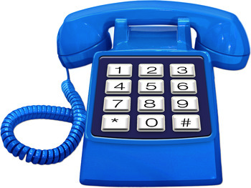 | Your telephone numbers:  Home:  Mobile:
 | Your email address:
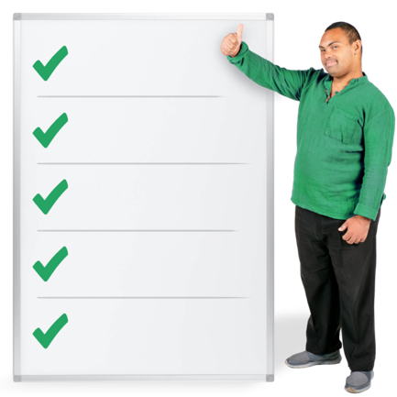 | What is the best way for us to contact you?   Phone   Email   Video call   Speak to my support worker or carer
Please tell us the contact details for your support worker or carer:

Name

Phone
 | Would you be able to travel alone to an event or would you need your gig buddy to travel with you?
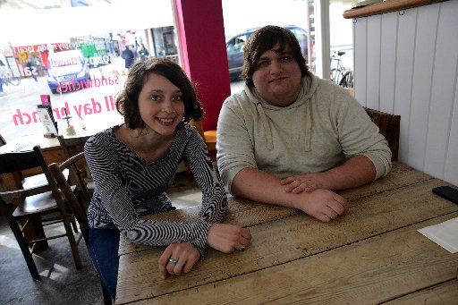 | What do you hope to get out of having a gig buddy?
 | What shows are you into? (this could be a genre, specific musicians, types of sports, or anything you like!)
 | What are your hobbies?
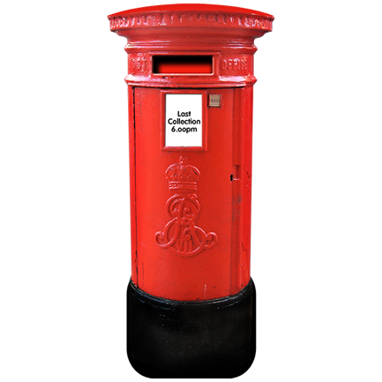 | Please send this form to either:  E-mail: admin@gigbuddiesbristol.com  Post: Gig Buddies Bristol  Exchange  72-73 Old Market Street  Bristol  BS2 0EJ

One of the team will then be in touch with you shortly to talk about what happens next.

